DYNAMIC SHARED MEMORY MANAGER

Project Motivation:
Dynamic shared memory manager is a memory manager in which we have created a shared memory using a text file. The Shared memory is properly initialized and also its structure, which contains Headers, blocks, etc. This Shared memory is used for interprocess communication between threads of multiple processes in which multiple threads can write some information in the text file i.e. the shared memory and any thread can read the information of any other thread. Now all this communication will occur in a synchronized manner using a binary semaphore called mutex in which when a specific process locks in while accessing the shared memory then the lock through mutex can only be unlocked by that process only. Now assume t1,t2,t3 threads are writing some information in the text file starting from some specific starting block and acquired some number of blocks, which may lead to external fragmentation due to which the situation may arise in which we will not be able to allocate blocks to some process’s thread even though requested memory is still free because that memory is not in a contiguous manner. So we need to apply some memory allocation strategies like First fit, best fit, worst fit, next fit using which we can decide how to give the threads the memory inside the shared memory.
Steps followed in code –
1. Created the shared memory first –
Firstly we have created a variable shm type SharedMemory(structure)
Find it in SharedMemory.h -
Shared Memory Structure –
Fd (file descriptor) fd uniquely identifies this shared memory object inside the OS/
shm size tells about the size of overall shared memory
shm_ptr Base pointer to mapped memory region (result of mmap())
MemoryHeader header* pointer to the shared memory region in shared memory
BlockInfo blockArray * Base pointer to the array of blockInfo structures which will give us the global view of blocks.
Dataregion pointer to start of actual memory where we have to write the data

MemoryHeader structure :
MemoryHeader stores the metadata or the complete information about how much memory is used and how much is free , mutex or a lock.
total_size - Total size of shared memory
used_size - Used size of shared memory
free_offset - The offset (from the start of the shared memory) where the next free memory byte begins.
block_array_offset - From the start of shared memory, where does the BlockInfo array begin.
pthread_mutex_t lock - A mutex stored inside the shared memory so multiple processes can synchronize access.

BlockInfo Structure :
Each BlockInfo entry describes one allocated or free block inside your shared memory.
Together, the array gives a global view of all memory blocks.
Pid – process’s id which owns the block
size – The actual size of the block allocated in the data region
isFree – Determine is the block occupied, if false yes, and true means no
offset - The offset (from the start of shared memory) where this memory block starts in the data region.

2. Initalize the Shared memory:
In main #define SHM_FILE "shared_mem.txt"
#define SHM_SIZE 65536 // 64 KB
initSharedMemory(&shm, SHM_FILE, SHM_SIZE); is called from main() to initialize the shared memory
In SharedMemory.cpp
In this we set the size of shared memory we want
Opened the file and stored its file descriptor
Used ftruncate() so as to make sure that the file shared_memory.txt has to be of size same as we want the memory regipn if it is smaller than 64KB expand the file , if is larger than 64KB then shrink the file
File created as shared memory –
shm->shm_ptr = mmap{
NULL, // you are telling OS, choose any available virtual address for me.
shm->shm_size, //mention the size
PROT_READ | PROT_WRITE, // permissions
MAP_SHARED, // changes are visible to all processes mapping the same shared memory
shm->fd, //mmap uses this fd to know what to map into memory.
0); // offset - Starting position inside the file to begin mapping

shm->header = (MemoryHeader*)shm->shm_ptr;//this will tell the user from which point on the file starts and we will store information like free space, used space
shm->blockArray = (BlockInfo*)((char*)shm->shm_ptr + sizeof(MemoryHeader));//block array is the reference of the starting block and it is after the shared memory
shm->dataRegion = (char*)shm->shm_ptr + sizeof(MemoryHeader) + sizeof(BlockInfo) * MAX_BLOCKS; //after both memory header and the block info structure array thats why used MAX_BLOCKS

3. Initialize the memory layout –
In SharedMemory.cpp
We are just intializing the memory header’s attributes by the information we have got till now and also initializing the blockinfo structure array such that it describes that there is no processes to which any block is allocated.
Important lines for synchronization purpose while multiple process communicates -
pthread_mutexattr_t attr; //this is just a mutex configuration object by which you set some attributes of mutex
pthread_mutexattr_init(&attr); //intialize this mutex
pthread_mutexattr_setpshared(&attr, PTHREAD_PROCESS_SHARED); //this is for the purpose that instead of threads of one process using the mutex we want threads of multiprocess can access it bercause we are in multiprocess environment
4. Created child processes for simulating multiple processes –
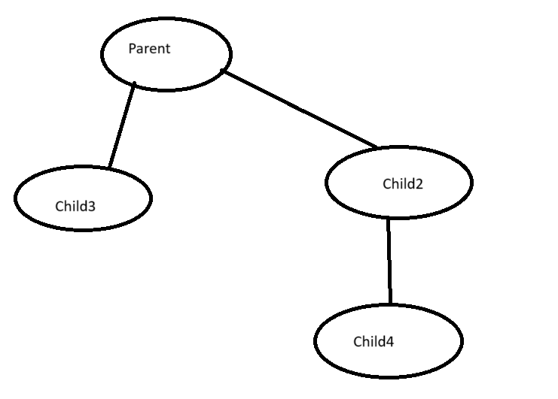
Actually 4 processes are created overall and as you can see in the code we are calling runProcess(&shm,getpid()) from the childs only.
So overall only 2 calls are made.
And at the end of the main() we wait for both the child to arrive (so that the program will not end after only process completes the job);
waitpid(pid1, nullptr, 0);
waitpid(pid2, nullptr, 0);
And at the very end we are printing the memory layout (information about how much allocated to which process’s thread) and destroying the shared memory which you could find in SharedMemory.cpp
printMemoryLayout(&shm);
destroySharedMemory(&shm); //destroy the memory mapped for parent also

5. RunProcess in main() –
In this we are creating an array of type pthread whose size is NUM_THREADS (3) defined at start which represents threads. Since we are calling this function for only 2 processes. Number of threads will be 6 so number of memory allocations will be 6 in total.
- Now suppose P1 arrives in runProcess
- 3 Threads will be created
- Declare an array of ThreadArgs structure in which you fill information about each of those NUM_THREADS like process id (which process do they belong to), shared memory pointer(shm), allocation size (manual in our case).
- pthread_create(&threads[i], nullptr, threadFunc, &args[i]);
Now each of these thread will be created and as soon as they are created then they call a function called threadFunc(args) where args represents the thread arguments, and this is the function responsible for alllocations in memory using strategies like First Fit, Worst Fit, Best Fit, Next fit algorithms.

ThreadArgs structure –
struct ThreadArgs {

SharedMemory* shm;//pointer to shared memory so that each thread could access the thread

int processID;//identifier that which process is using the Thread

int allocationSize;//specifies the size of memory requesting to allocated
};

